Last to Finish: The Smartest Boy in Math Class
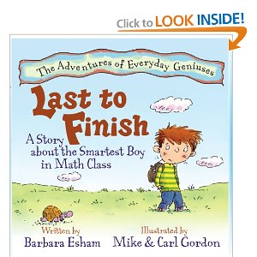
Last to Finish is about, Max, the Smartest Boy in Math Class. This is our second book from the series, Adventures of Everyday Geniuses. In the story, third-grader Max loves and is doing well in math until he has to take a timed test on multiplication facts. Before timed tests Max solved problems accurately, but as soon as the teacher sets that timer….. he is unable to focus. He describes the terror this way:
“As soon as Mrs. Topel starts the timer,
my heart begins to pound,
my hands begin to sweat,
and then the worst thing happens……….
my mind frees.”

Max doesn’t understand why, “…. the math facts are erased from his mind while he sleeps,” and “2 x 3 suddenly looks like an alien message that can only be deciphered by scientists.”
Unfortunately, a few of Max’s classmates start to tease him and shout out chants such as,
“Max, Max last in math.”
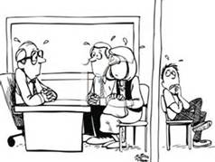
Then things get worse for Max. His teacher and principal request to meet with his parents to discuss Max’s math ability. Max is sure his parents will be disappointed in him when they hear that Max is the worst math student in the history of the school. Mr. and Mrs. Leonhard and Max are shocked when the principal tells the family the complete opposite. Max is actually very good at math – so good that he is asked to join the school’s math team and work in a program for accelerated math students.
How can this be? Max has failed every timed test. Along with readers, the Leonhard family learns that there are different kinds of intelligence. Max is a learner who has a deep understanding of the way numbers work. Understanding and memorizing are not the same depth of learning. The principal explains how some people are great at memorizing all sorts of information, while others are better at understanding information. He goes on to say,
“If I could choose between the two, I would rather have students understand mathematics rather than just memorize facts.”
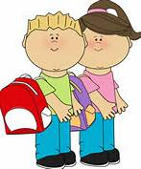
Last to Finish lends itself to discussions about:
- Understanding your learning style
- How the brain learns
- Overcoming test anxiety and fear of failure
- Debate between memorization and comprehension
- Myths about gifted children
- Twice exceptional learners

Learning Styles/Multiple Intelligences
We highlighted learning styles in a previous book study. (Please see: http://www.hasd.org/curriculum/2013bookstudyonsocialandemotionalneeds.cfm
Sometimes it is hard for our gifted learners to recognize and understand that they are “smart” in different ways and that they can’t be “smart” about everything. For some, this realization hits when they hit middle school because concepts and skills came easily to them in the elementary grades. The main theme of, Last to Finish, we all learn differently, can provide a reassuring message for children and even advice for parents and teachers.
Ask your child, what does it mean to be smart? Often time children will say that being smart means you:
- read really well
- get good grades
- do well on tests
- solve math problems quickly
- recite a bunch of facts
True, those are a few of the characteristics of smart people, but there are many other ways to show your intelligence, gifts and talents – through art, music, athletics, nature, working with others, nature and emotions.

Type of Intelligence | Examples of Relevant Behaviors
Linguistic Intelligence  Ability to use language effectively | - Making persuasive arguments  - Writing poetry  - Identifying subtle nuances in word meanings
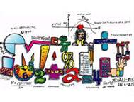  Logical-Mathematical Intelligence  Ability to reason logically, especially in mathematics and science | - Solving mathematical problems quickly  - Generating mathematical proofs  - Formulating and testing hypotheses about observed phenomena
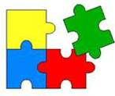  Spatial Intelligence  Ability to notice details of what one sees and to imagine and manipulate visual objects in one's mind | - Conjuring up mental images  - Drawing a visual likeness of an object  - Making fine discriminations among very similar objects
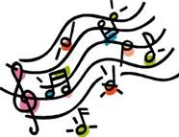  Musical Intelligence  Ability to create, comprehend, and appreciate music | - Playing a musical instrument  - Composing a musical work  - Showing a keen awareness of the underlying structure of music
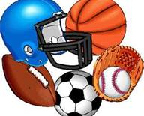  Bodily-Kinesthetic Intelligence  Ability to use one's body skillfully | - Dancing  - Playing basketball  - Performing pantomime
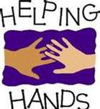  Interpersonal Intelligence  Ability to notice subtle aspects of other people's behaviors | - Correctly perceiving another's mood  - Detecting another's underlying intentions and desires  - Using knowledge of others to influence their thoughts and behaviors
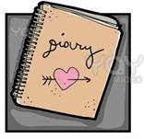  Intrapersonal Intelligence  Awareness of one's own feelings, motives, and desires | - Discriminating among such similar emotions as sadness and regret  - Identifying the motives guiding one's own behavior  - Using self-knowledge to relate more effectively with others
Naturalist Intelligence  Ability to recognize patterns in nature and differences among natural objects and life-forms | - Identifying members of particular plant or animal species  - Classifying natural forms (e.g., rocks, types of mountains)  - Applying one's knowledge of nature in such activities as farming, landscaping, or animal training

We can’t be good at EVERYTHING, but we do have some ability in each of the areas described in the table. Thomas Armstrong shares some good news:
- All of the intelligences are different, but they are also equal. No intelligence is more important than another.
- No matter what kind of ability you have in a given area, you can explore, grow and develop it. Whether you have trouble spelling the word “dictionary” without looking it up in the dictionary or you’re a future best-selling author, you can become more Word Smart.
- There are many different ways of being smart in each intelligence. For example if you are Word Smart, you might discover that you’re a top-notch speaker but not such a terrific writer. Or for Body Smart, you might excel in soccer, but you can’t swim one lap. With some work, you can build on your strengths and improve your weaknesses.
- You may know what you are best at, but that doesn’t mean you are limited to one type of intelligence. Maybe you are Body Smart. Don’t let that stop you from reading lots of books or learn to paint.
- The different smarts work together in almost everything you do.
Armstrong, Thomas. You’re Smarter Than You Think – A Kid’s Guide to the Multiple Intelligences. 2003. Minneapolis, MN.
Help your child understand his/her learning style by taking one or two of the online surveys below.
http://www.literacyworks.org/mi/assessment/findyourstrengths.html
http://www.bgfl.org/bgfl/custom/resources_ftp/client_ftp/ks3/ict/multiple_int/questions/questions.cfm
What the Kids Have to Say
Last to Finish also brings up the topic, what are our gifted and talented students saying about school, friends and other people’s perceptions. The following are some interesting perspectives:
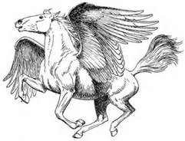
Myths About Gifted Children
- Gifted kids have it made and will succeed in life no what.
- Gifted kids like school, always get good grades and greet each new school day with enthusiasm.
- Gifted children only come from white, middle to upper class families.
- Gifted kids are good at everything.
- Teachers can easily identify gifted students and like to work with them better than any other student.
- If gifted students are grouped together, they will become snobs or elitists.
- All gifted kids have trouble adjusting to school and friends.
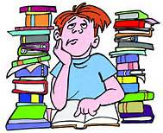
Eight Gripes of Gifted Kids
- The stuff we do in school is too easy and it’s boring.
- Parents, teachers and friends expect us to be perfect and to do our best ALL the time.
- Friends who really understand us are few and far between.
- Lots of our coursework is irrelevant.
- Peers often tease us about being smart.
- We feel overwhelmed by the number of things we can do in life.
- We feel too different and alienated.
- We worry a lot about world problems and feel helpless to do anything about them.
Galbraith, Judy, The Gifted Kids’ Survival Guide. 2001. Minneapolis, MN.
Ten Common Concerns Gifted Students Have About Their Friends
- I have trouble getting them to understand me.
- It’s hard to get along with kids my own age.
- I hate being labeled “gifted” by kids. It makes me feel too different.
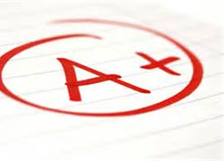
- I hate being teased about being smart.
- Kids tease me when I DON’T get A’s all the time.
- Kids tease me when I DO get A’s all the time.
- My friends don’t really understand me. Sometimes I feel like I’m way over their heads.
- I don’t like it when somebody gives me the brush-off from doing better than they do.
- I have trouble coping with the way peers act. Sometimes they seem so silly.
- It’s hard to ignore peer pressure without your friends thinking that you are ignoring them.
Galbraith, Judy, The Gifted Kids’ Survival Guide. 2001. Minneapolis, MN.

How the Brain Learns
Last year’s book study focused on how the gifted brain learns. (http://www.hasd.org/curriculum/gatebookstudy2012-2013.cfm)
This month I would like to share an interesting and informative website with you. Brain Rules offers interactive tutorials, summaries of the “12 Things We Need to Know About the Brain,” (no need to purchase the book) and short videos about understanding and improving brain power. (http://www.brainrules.net/THE-RULES)

Twice Exceptional Learners
Share some interesting facts about other “famous” gifted learners who weren’t always considered smart.
A Few Gifted Students Who Made Them Eat Crow
- Beethoven’s music teacher once said of him, “As a composer, he is hopeless.”
- Winston Churchill failed the 6th grade and finished last in his class.
- Walt Disney was fired by a newspaper editor because, “he had no good ideas.”
- Louisa May Alcott was told by an editor that she could never write anything that had popular appeal.
- Charles Darwin, who originated the theory, “Origin of the Species,” quit medical school.
- Isaac Newton did poorly in school.
- Thomas Edison’s teacher called him, “addled.”
- Bill Gates was banned from his high school’s computer lab.
Famous people who are dyslexic
Hans Christian Andersen | Author of children's fairy tales
Cher | Entertainer, actress
Tom Cruise | Actor
Leonardo Da Vinci | Renaissance artist, sculptor, painter
Walt Disney | Cartoonist, visionary founder of Disneyland/Disneyworld
Albert Einstein | Scientist, philosopher
Tracey Gold | Actress
Whoopi Goldberg | Actress
Bruce Jenner | U.S. Olympic Gold Medalist
Magic Johnson | Professional athlete
Greg Louganis | U.S. Olympic Gold Medalist
George Patton | Military General
Patricia Polacco | Author, illustrator of children's books
Nelson Rockefeller | Former governor of New York, former vice president of the United States
Nolan Ryan | Professional athlete
Lindsay Wagner | Actress, author, "The Bionic Woman"
Woodrow Wilson | Former president of the United States
Henry Winkler | Actor, director, humanitarian, "The Fonz"
Famous people with appearance differences
Helen Keller | Author
Stevie Wonder | Singer
Famous people with movement differences
Muhammad Ali | Former professional athlete
Michael J. Fox | Actor
Annette Funicello | Actress
Billy Graham | Religious leader
Stephen Hawking | Astrophysicist
Pope John Paul II | Religious leader
Christopher Reeve | Actor
Janet Reno | U.S. Attorney General
Franklin Delano Roosevelt | Former president of the United States
Famous people with speech differences
Ludwig von Beethoven | German composer
Joseph Biden | U.S. Congressman
Lewis Carroll | Author
Bill Clinton | U.S. President
Winston Churchill | Former Prime Minister of Britain
Walter Cronkite | Journalist
Kirk Douglas | Actor
Stephen Hawking | Astrophysicist
Florence Henderson | Actress
James Earl Jones | Actor
Helen Keller | Author
Marlee Matlin | Actress
Marilyn Monroe | Actress
Carly Simon | Singer
Richard Thomas | Actor
John Updike | Author

